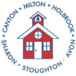 | Jones School, 137 Walnut Street • Stoughton, Massachusetts 02072  (781) 344-1463 • Fax: (781) 344-5299

CHARMS COLLABORATIVE

ANNUAL REPORT

FY14

Quality Education….Community Partnerships

Prepared by
Rosalie O’Connell, Executive Director
Ellen Whittemore, Business Manager
December 2014

Introduction

In accordance with Section 43 of the Acts of 2012, Charms Collaborative has prepared the Annual Report and Audit for FY14. The Charms Board has reviewed and approved the documents. The Annual Report and Audit will be posted for public review and shared with all member school committees.

FY14 was exciting school year for the Charms Community. We serviced students from twenty eight districts in Massachusetts. Increased collaboration between programs, staff and the community allowed us to enhance service delivery and expand upon community partnerships.

As we continue to strengthen our services, we look forward to additional districts utilizing our educational opportunities for their low incident special education populations.

The FY14 Annual Report is submitted by Rosalie O’Connell, Executive Director/Program Director and Ellen Whittemore, Business Manager

Respectfully submitted,

Rosalie O’Connell
Executive Director/Program Director
Charms Collaborative

General Information

Administrative Office Location:
Jones Elementary School
137 Walnut Street
Stoughton, MA 02072

Office Phone: 781-344-1463
Office Fax: 781-344-5299

Charms Collaborative Website www.charms-collaborative.org

GOVERNANCE

Board of Directors:

Avon Mr. Paul Zinni Superintendent of Schools

Canton Mr. Jeff Granatino Superintendent of Schools

Holbrook Dr. Patricia Lally Superintendent of Schools

Milton Ms. Mary Gormley Superintendent of Schools

Sharon Mr. Timothy Farmer Superintendent of Schools

Stoughton Dr. Marguerite Rizzi Superintendent of Schools

Treasurer:

Donna Erickson

Operating Committee:

Avon Ms. Christine Godino

Canton Ms. Deborah Bromfield

Holbrook Ms. Cheryl Flynn

Milton Ms. Karen Clasby

Sharon Mr. Steve Kaplan

Stoughton Ms. Heather Tucker

CHARMS ORGANIZATION CHART

CHARMS Board of Directors

Business Manager
Treasurer Directors
Professional Staff
Para-Professionals
Executive Director/Program Director

Executive Assistant
Payroll – H/R Administrator

Charms Collaborative
FY14

Guiding Beliefs

We believe….

- Each student has intrinsic worth and unique needs

- All students have the ability and need to learn

- All students can learn in appropriately individualized programs

- In providing Professional Development for staff in order to provide current educational strategies to our students.

- All Collaborative programs are an integral part of the Charms community

- Public awareness is the responsibility of the entire Charms community

- In a community partnership to strengthen resources and communication.

- All students have a right to a quality education with high expectations

- All students have the right to learn in a safe and secure environment

- Our diverse Charms communities provide strength for our programs and services

- Collaboration creates a comprehensive continuum of services

- Parents are their children’s most important advocates

Mission and Purpose

Pursuant to M.G.L. Chapter 40, Section 4E and 603 CMR 50.00, the mission and purpose of the Collaborative is to jointly conduct and create educational programs and services for Member Districts and neighboring school districts when it is determined that such Collaborative programs and services can:

- Provide effective and efficient programs and services on a regional basis.
- Offer cost-effective options.
- Increase educational opportunities for children ages 3-22.
- Improve educational achievement for students with low-incidence disabilities in the least restrictive environment.
- Nurture community-based opportunities in order to expand independent living skills and support transitions.
- Provide professional development opportunities, staff training and consultation.
- Provide contracted services to school districts in order to promote and strengthen cooperative action on behalf of the students.
- Support parents as part of the Educational Team.

Focus

Pursuant to M.G.L. Chapter 40, Section 4E and 603 CMR 50.00, the focus areas of the Collaborative are the creation of special education programs and services in the least restrictive environment, comprehensive professional development within local communities of the member and neighboring school districts and the strengthening of family engagement in the educational process.

Goals and Objectives

Pursuant to M.G.L. Chapter 40, Section 4E and 603 CMR 50.00, the overall goals and objectives of the Collaborative include:

- 1. To provide quality programs to meet the on-going and changing needs of students.
- To administer annual internal evaluations and needs assessments of each program.
- To conduct periodic external reviews/evaluations of current and future programs.
- To provide inclusive, sequential programs with a continuum of educational services and facilities within communities.
- To provide on-going communications with Member and Non-Member Districts regarding collaborative programs in order to support their needs.

- 2. To create and maintain a stable financial infrastructure.
- To consider increasing Charms membership in order to expand programs.
- To pursue grants and other funding to support identified district needs in a cost-effective manner.
- To provide quality, cost-efficient professional development.
- To provide quality, cost-efficient contracted services to districts.

- 3. To provide comprehensive professional development opportunities for both Charms and districts.
- To develop and implement a comprehensive assessment process to meet Collaborative and district professional development needs.
- To provide staff training to meet local, state and federal regulations.
- To provide staff development that sustains and enhances present programming within the Collaborative.

- 4. To support relationships and outreach to staff, parents and community in order to enhance awareness and communications.
- To provide an on-going internal mechanism to increase dialogue and problem solving activities within the Collaborative and community.
- To update the Collaborative website in order to share information and
- provide immediate access to information in accordance with the laws.
- Increase community awareness and student involvement in the local communities

Progress Toward FY14 Goals

- Accomplishments for Goal #1-Quality Programming:
- Program overviews were updated to better identify the student population.
- Individual student needs were analyzed and changes made to better meet all needs.
- Curriculum implementations were reviewed and updated
- Staff goals were centered on programming enhancements
- Community Partnerships were developed and increased.
- Preliminary outline to implement sequential programming.
- Newsletters, Twitter and Website were used to increase communications with our communities.
- Implementation of Teacher Evaluation Process

- Accomplishments for Goal #2-Financial Infrastructure:
- FY14 revenue and expenses analyzed to determine needs and cost efficiency.
- Costs associated with services were reviewed in order to increase or decrease as necessary to best meet the individualized needs of our students.
- Cost efficient opportunities for Professional Development offered.
- Grants through DESE and Community Partnerships.
- Increase in availability of contracted services to districts.

- Accomplishments for Goal #3-Professional Development:
- Over 50 hours of Charms Professional Development were offered to Charms staff in FY14
- Professional Development Opportunities for Charms staff and neighboring districts offered
- Charms Staff Expertise utilized to provide Professional Development
- Budget available for individual staff PD.

4. Accomplishments for Goal #4- Outreach
- Increased communications with staff, districts, communities and parents
- Website and Twitter
- Community Partnerships Developed and Increased

Charms Collaborative Overview

Charms Educational Programs

- Multi Skills I
- Multi Skills II
- Elementary Learning Skills
- MS Alternative Learning
- HS Alternative Learning
- Vocational/Life Skills

Charms Collaborative Services

- Home Services

- Vision Services

- Physical Therapy Services

- Occupational Therapy Services

- Orientation and Mobility Services

- Speech and Language Therapy Services

- Evaluation Services

- Professional Development

- Health Care and Nursing Services

General Statistics

Years in Service 37
Employees 46
Member Districts 6
Districts Served 21
Programs 6
Program Sites 6 – Canton (3), Sharon (1), Stoughton (1)

Charms Collaborative Staff FY14

Administrative Team

Executive Director/Program Director Rosalie O’Connell
Business Manager Lincoln Lynch
Human Resources/Payroll Sheila Anderson
Administrative Assistant Jackie Bessette

Staff Demographics

Administration 2.0
Administrative Support 2.0
Teachers 11.0
School Adjustment Counselors 1.6
School Psychologist 1.0
Nurses 3.0
Speech Therapists 3.0
Physical Therapists 1.0
Occupational Therapists 2.0
Orientation and Mobility 0.25
Teachers of the Visually Impaired 1.9
Educational Assistants 16.0

TOTAL STAFF (FTE) 44.75

Highlights of Achievements for FY14

- Continued Partnership with Old Colony YMCA in Stoughton
- Student Volunteers
- Health Education
- Spring Dance
- Shape Grant
- Food Pantry

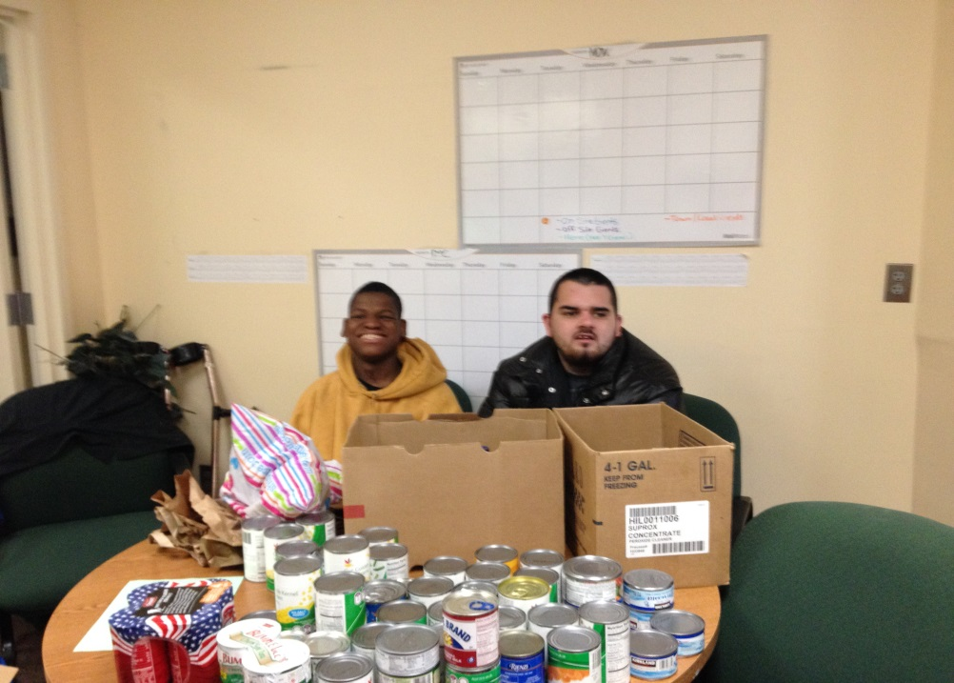
Sorting food donations at the Old Colony YMCA

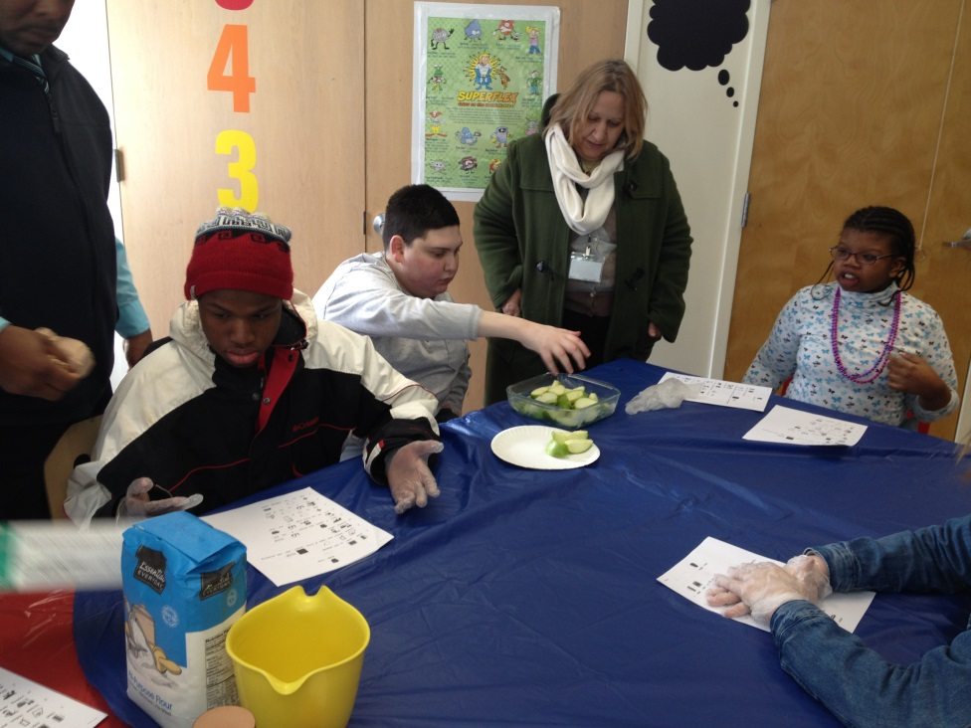
Making lunch at the Y
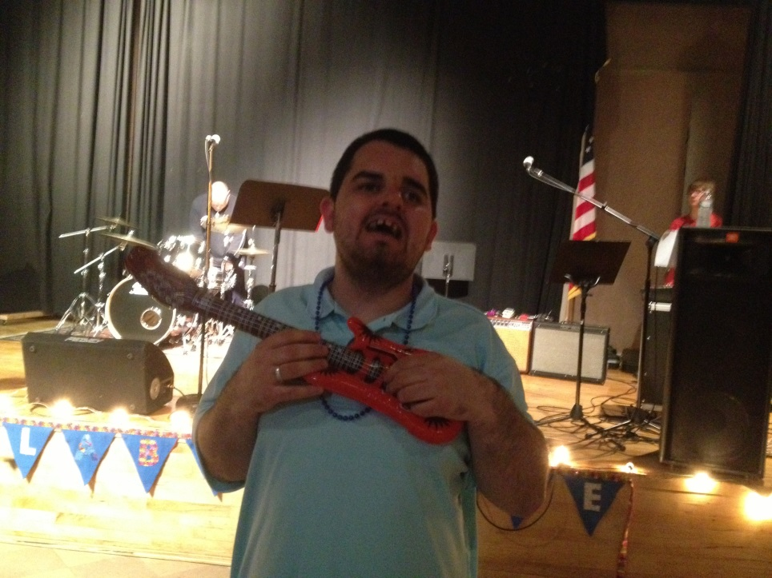
Second Annual Charms Dance at Old Colony YMCA June 2014

- Mass Hospital School
- Student Animal Care
- Therapeutic Horseback Riding

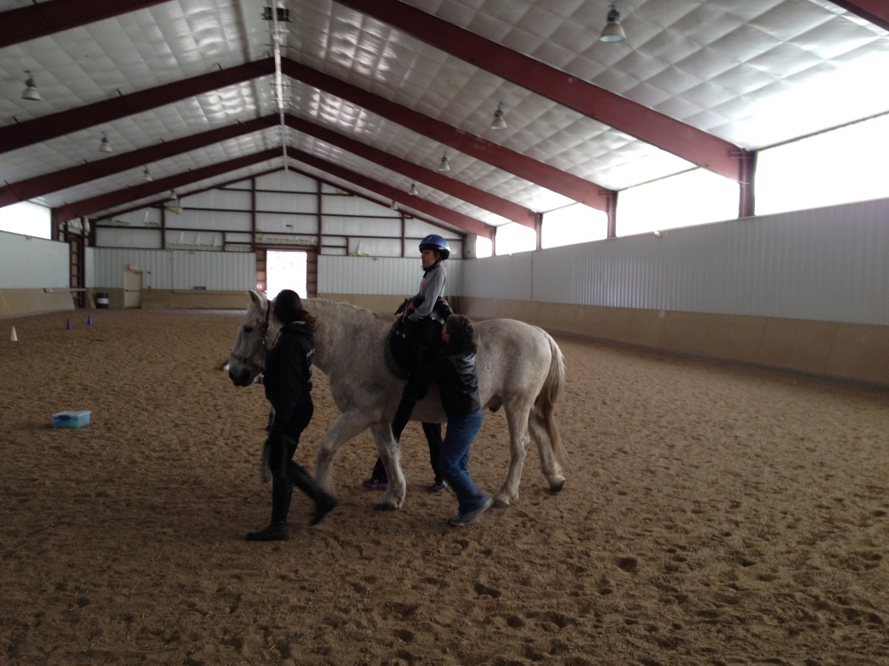

- Special Olympics Spring 2014
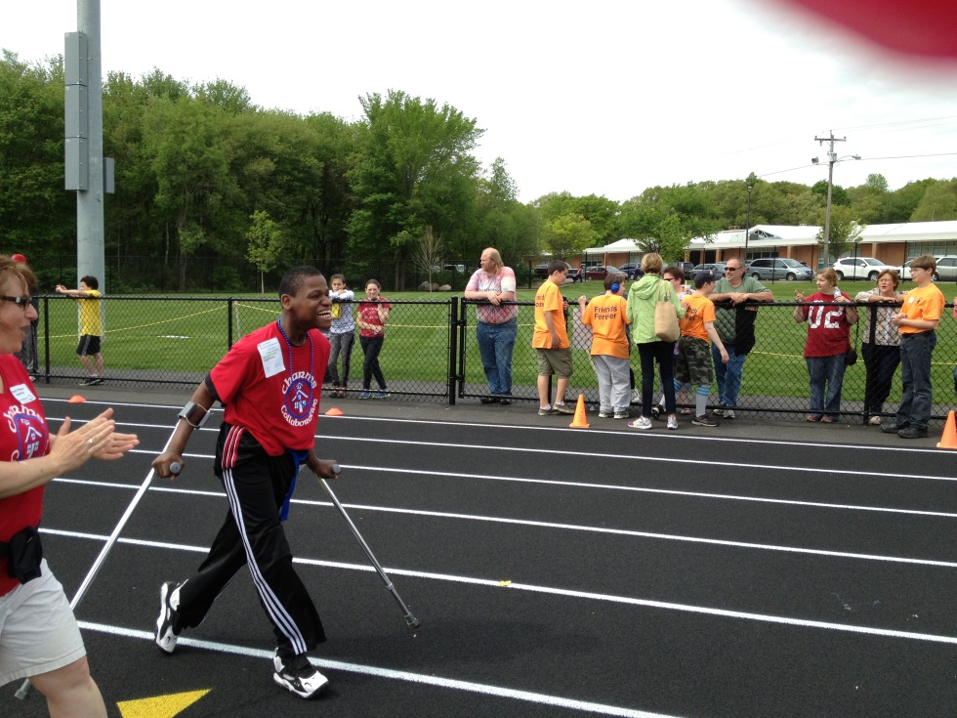

- Transitioning Ceremony June 2014
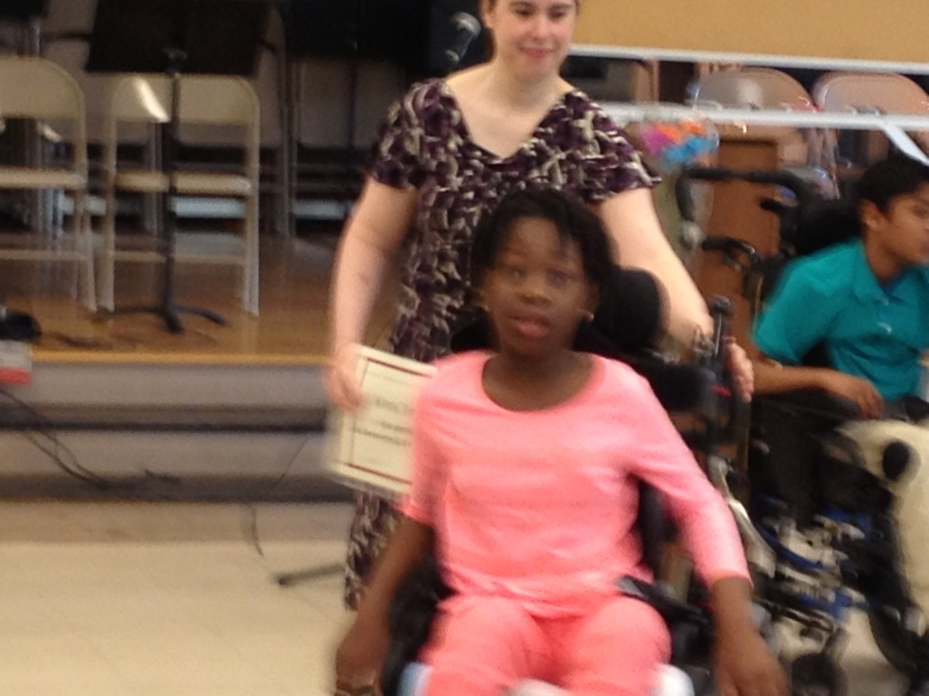

- Professional Development Opportunities Offered in FY14:

  - Regulations for Educational Collaboratives
  - Confidentiality and Privacy of Educational Records
  - Educator Evaluation Workshops
- Chapter 222-Student Access to Educational Services and Exclusion from School
- IEP Process and Esped Training
- Balanced Literacy Classroom Support
- Transition Planning
- Behavior Supports and Implementing Behavior Plans
- Writing Informational Incident Reports
- Developing and Implementing Functional Behavior Assessments
- Bullying
- Homelessness
- Health Related Topics:
* Blood Borne Pathogen Training and Review
*Allergies, Anaphylaxix and Epinephrine Administration

- Grants
  - Special Education Program Improvement Grant 274
$885

Educational Programs and Services
FY14

Elementary Learning Skills: East Elementary School
Sharon, Massachusetts

This program is for students ages 7-12 years old with disabilities and deficits in the following areas:
*atypical development, autism and other pervasive developmental disabilities;
*developmental communication disorders, including atypical development with related difficulties with motor systems and language development;
*cognitive, sensory processing, learning and social-emotional needs.
The students in the program have both education and social similarities but each student is seen as an individual with a personalized program to meet their individualized needs. Our program maintains a highly structured, multisensory individualized diagnostic-prescriptive setting, which includes small group of 1:1 and 1:2 instruction. Within our classroom, the staff has the unique ability, through educational training and many years of experience, to identify, develop, and implement academic, therapeutic, and behavioral goals that encourage our students to capitalize on their strengths and successes while making progress in areas of need.
Academics and Related Services:
Our program is a language based, developmental classroom in which students are given the opportunities to practice and master skills in a natural learning environment. Educational experiences are constructed to develop and reinforce cognitive, language, social-emotional, behavior and physical skills. The curriculum is individual tailored, adapted and implemented to accommodate and support each student’s needs and abilities. Within the classroom environment each child’s academic level is determined by developmental learning standards. Tasks and activities are designed to challenge the learning curve of the student through errorless learning, task analysis and building upon each previously learned and mastered skill through review, modeling, imitation and opportunities for repeated practice. Instruction includes work in language arts, balanced literacy, technology, social skills and sensory motor integration, fine & gross motor skills, social skills, technology and activities of daily life.

Multi Skills 1: South Elementary School
Stoughton, Massachusetts

A program designed for students ages 10 to 13 with multiple disabilities including but not limited to severe to profound, developmental disabilities, cerebral palsy, vision impairment, and communication disorders and hearing impairment.

Academics and Related Services:
The program follows the Massachusetts Curriculum Frameworks which we will modify to meet each individual students needs based on their incoming knowledge and skills. All of our academic lessons are taught with a one to one ratio with the Special Education teacher. A total communication approach is utilized in order to best meet students’ needs. We have nursing, music, therapy, physical therapy and speech therapy personnel to meet developmental, communication, functional and health goals. Students receive therapeutic services on a consistent basis based on their needs. Services include: Speech & Language Therapy, Occupational Therapy, Physical Therapy, Music Therapy and Adaptive Motor groups. All therapies are generalized to the classroom setting in order to practice and help maintain skills.

MS Alternative Learning Program: Galvin Middle School
Canton, Massachusetts

This program is for students ages 12-14 who require an academic therapeutic setting that allows access to the general education curriculum with additional support for academics, social, emotional and behavior skills. We serve students who have low to above average intelligence who exhibit one or more of the following disabilities or differences: language-based learning, non-verbal, PDD, communication, anxiety, depression, adjustment disorders and social-emotional fragility. Staff is trained to maintain a therapeutic rapport with each student while providing a safe environment to facilitate learning and promote self-confidence. The staff collaborates to further each student’s academic and social growth by embedding social and interpersonal skills, social competencies and conflict resolution into the daily routine.

Academics, Interventions and Related Services:
The academic curriculum follows the Massachusetts Curriculum Frameworks. All students are included into general education classes as much as possible based on their individual needs. Inclusion is designed to enhance socialization, promote friendships and strengthen academic skills. Students may be accompanied by a CHARMS staff member who helps support the student as needed. Increased independence within inclusion classes is provided as appropriate. Within the self-contained classroom students receive small group instruction as well as study skills support. Scheduling flexibility allows the instruction to meet the individual learning needs of our students. We offer a highly structured therapeutic milieu with clinical support services to assist with social growth opportunities, crisis management and communication between school, families and outside agencies.

HS Alternative Learning Program: Canton High School
Canton, Massachusetts

This program is for students age 14-19 that require an academic/ therapeutic setting that allows them to access the general education curriculum with additional support for academics, social, emotional and behavior skills. We serve students who have average to superior intelligence who exhibit one or more of the following disabilities or differences: language-based learning, non-verbal, PDD, communication, anxiety, depression, adjustment disorders and social-emotional fragility. Our staff is trained on how to maintain a therapeutic rapport with each student. Study skills and lifelong learning skills are taught to ensure that when students leave the program, they are ready for their next step.

Academics, Interventions and Related Services:
The academic curriculum follows the Massachusetts Curriculum Frameworks in preparation for college/post-secondary education. All students are included into general education classes as much as possible based on their individual needs to enhance socialization, promote friendships and strengthen academic skills. Students may be accompanied by a CHARMS staff member who helps support the student as needed. Within the self-contained classroom students receive small group instruction as well as study skills support. Scheduling flexibility allows the instruction to meet the individual learning needs of our students. Social-emotional and study skills supports are essential goals of the program is to build relationships with each student in order to be able to help develop skills and offer supports around their academics and their social-emotional well-being. Our counselors provides individual counseling to each student as well as group sessions and as needed supports.. The staff collaborates to further enhance each student’s academic and social growth by embedding social and interpersonal skills, social competencies and conflict resolution into the daily routine

Vocational/Life Skills: Sharon High School
Sharon, Massachusetts

This program is for students ages 15-22 who require support in the areas of functional life skills and vocational training in preparation for independent living and potential employment. Student disabilities include intellectual, emotional, communication and autism. The staff works with the parents, districts and outside agencies to ensure appropriate transition plans based on individual student needs. Students typically graduate upon turning 22 years old. All past graduates are active, contributing members of their communities; most are in paid work programs or are competitively employed, and a few are in day habilitation programs.

Academic and Related Services:
The academic curriculum includes functional math, reading, writing, language arts, social skills, and health/wellness. The curriculum prioritizes the application and generalization of all skills to facilitate students’ success in vocational, school and community settings. Community/classroom based learning activities include: social skills, banking, eating at restaurants, community safety skills, using a public library, budget planning, shopping, food preparation, meal planning and health/hygiene. Students are also encouraged to participate in a variety of inclusion classes depending upon their interests and abilities.

Vocational
The comprehensive vocational curriculum includes job placement, job coaching, resume development/job application skills, vocational counseling, and job interview preparation skills. Vocational training at Sharon High School includes the following: school store (cashier, greeter, and inventory), culinary preparation for the cafeteria, library, clerical office support, mail sorting/delivery, copying and collating. Copley Nursing Home, Sharon Public Library, Medfield Village Cleaners and Brockton APCSM Animal Shelter are some the current community training placements.

Multi Skills II Programs: Rodman Building
Canton, Massachusetts

For students ages 15 to 22 years old with moderate to severe special needs in the areas of health, intellectual, autism, cerebral palsy, seizure disorders, hearing and visual impairments, central nervous system disorders and related disturbances of behavior and other social relationships. These programs are a continuation of a public school placement for pre-adolescent youth with severe and profound developmental disabilities and related functional handicaps. There are needs in the domains of functional academics, behavior, communication, self-care, activities of daily living and pre-vocational training which can be met with a 1:2 or a 1:3 programming ratio. We have intensive services in allied health fields to meet developmental, functional and health goals for students with more profound needs. Our main goal is to work with each student in areas such as academics, social skills, health & wellness, communication, daily living skills and behavior in order to maximize and expand upon their skill set in order to best prepare them for post 22 successes.
Students typically complete the program when they turn 22 years old. Previous students have typically gone into paid work-programs or are competitively employed. Some go on to other programs, living situations or daily workshops. The staff works with the parents, districts and outside agencies to ensure appropriate transition plans based on individual student needs.

Academic and Pre-Vocational
The academic curriculum includes functional math, reading, writing, language arts, social skills, and health & wellness. The curriculum prioritizes the application and generalization of all skills to facilitate students’ success in vocational, school, and community settings. Our team works with the students on communication development, pre-vocational training, transitional preparation, group dynamics, and peer interactions. Students meet the MCAS requirements by completing a portfolio as an alternative assessment. Our therapies include music, physical, occupation, speech/language and communication. Pre-vocational training is implemented in the classroom to teach our students pre-vocational and vocational skills.

Charms Collaborative Program and Student Data FY14
 | Total Number of Classrooms | Total Number of Students | Member District Students | Non-Member District Students
Multi Skills I: South Elementary School | 1 | 2 | 2 | 0
Elementary Learning Skills: East Elementary School | 1 | 6 | 2 | 4
MS Alternative Learning Program: Galvin Middle School | 1 | 4 | 3 | 1
HS Alternative Learning Program: Canton High School | 1 | 10 | 2 | 8
Vocational/Life Skills: Sharon High School | 1 | 18 | 13 | 5
Multi Skills II Programs: Rodman Building | 1 | 14 | 4 | 10
TOTALS | 6 | 54 | 26 | 28

